GVN Position Paper: Recent Ebola Virus Outbreaks in Central Africa

Background
Ebola virus and the related Marburg virus belong to the Filovirus family and cause severe hemorrhagic fevers with unusually high fatality. Outbreaks of filoviruses take place in Central Africa and have been occurring with more frequency during recent years. An outbreak in Uganda has been raging since July of 2012, and amazingly, another outbreak in the Democratic Republic of the Congo (DRC) began in August and is still going strong (throughout September). Since the two outbreaks occurred almost simultaneously but involved two different strains of ebolavirus, it is possible that the two viruses share a natural reservoir host that sheds virus abundantly during summer months (1, 2).

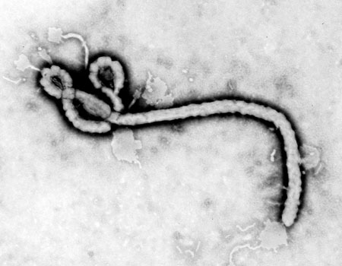
The first electron micrograph of a filovirus taken by Fred Murphy at the U.S. CDC, currently at UC Davis.

Filoviruses can cause severe hemorrhagic fever with 25-90% lethality. These viruses have a relatively rapid incubation period of 2-21 days. Initial symptoms include fever, headache, joint and muscle aches, followed by vomiting, diarrhea, clotting dysfunction, and sometimes rash and bleeding. Death usually occurs by multiple organ dysfunction, disseminated intravascular coagulation and tissue necrosis (1).
The Filovirus family includes three genera: Ebolavirus, Marburgvirus, and Cuevavirus (newly discovered in Spanish bats). The Ebolavirus genus includes 5 species: Reston virus (RESTV), Sudan virus (SUDV), Ebola virus (EBOV; formerly Zaire virus), Tai Forest virus (TAFV; formerly Coted'Ivoire virus), and Bundibugyo virus (BDBV). These species are ~50% divergent in protein sequence and show little serological cross-reactivity (3,4). EBOV is nortorious for causing 280 deaths in 1986, 250 in 1995, and 187 in 2007. SUDV (~70% lethality) is responsible for the recent Uganda outbreak, and BDBV (~50% lethality) is responsible for the recent DRC outbreak (1, 2). As a result of the significant differences among these viruses, development of separate vaccines and therapeutic strategies may be necessary.
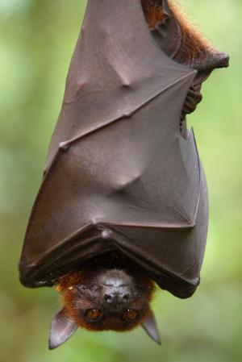
While for Marburg virus it is now well established that fruit bats represent the natural reservoir from which the infection spills over to the human population, the natural reservoir of the ebolaviruses is currently unclear, but is also likely to be a fruit bat (5). The wide geographic range of these bats, the potential for amplification of these viruses in both wild and domesticated animals (6), recent discovery of new ebolavirus species (7), climate change and instability in endemic regions suggest that outbreaks will continue to occur in Africa, potentially with increasing frequency.
RESTV exists in the Philippines where it has been found among primates (8-10) and recently, in herds of domesticated swine (11-12). The infection in swine spreads through respiratory secretions and is usually asymptomatic (13). Curiously, RESTV is not yet known to be lethal to humans, although it is highly lethal to nonhuman primates. So far the documented number of people exposed to Reston virus-infected animals was small (15 healthy adult males) (14); so it is possible that RESTV could be pathogenic in children, the elderly or the immune-compromised. Policies must be developed for dealing with a virus that is not causing disease but is infecting domestic animals: one must weigh the "potential threat" with the immediate environmental and economic impacts. (see the WHO discussion on culling the Reston pigs, ref. 14).
There are no currently approved drugs or vaccines for use in humans, and current treatment options involve only supportive care, such as i.v. fluids. Candidate vaccines, however, have shown tremendous promise in nonhuman primates (15-17). In these vaccines, key viral antigens are displayed on the surface of nonlethal carrier viruses like vesicular stomatitis virus (VSV). Such vaccines provide an excellent preventative option for persons of likely exposure (scientists, animal handlers, medical personnel in outbreak sites) as well as humans and endangered nonhuman primates in endemic regions (18,19). In some cases, these vaccines have shown efficacy as post-exposure prophylaxis (20,21), an extremely important attribute as outbreaks can be difficult or impossible to predict.

Analysis
Outbreaks of filoviruses are always accompanied by considerable public interest and, often, panic. In some places Ebola fever is considered witchcraft and sick people are socially stigmatized. This negatively impacts the compliance of the population concerning epidemiological investigations and isolation measures and, ultimately, the containment of the outbreak.
When filovirus infection is suspected in an outbreak, the most urgent task is rapid diagnosis. A diagnosis will motivate the community and hospitals to strengthen precautions and to get aid from first-responders. Few laboratories in Africa are able to perform proper filovirus diagnostics. Among them the Uganda Virus Research Institute (UVRI) in Entebbe, Uganda, the Special Pathogens Unit (SPU), the National Institute for Communicable Diseases (NICD) in South Africa and the International Centre for Medical Research in Franceville (CIRMF) in Gabon. Very often, however, it is the special pathogens branch of the US-CDC, which is finally asked to help with diagnosis. This means that unnecessary time elapses before isolation measures are put in place.
At the beginning of an outbreak, first-responders and their personal protective equipment must be transported to the outbreak sites, which are often located in remote rural areas. In addition patient management and isolation wards have to be set up, social mobilization teams have to be established and epidemiological investigations to identify contacts must be done. Therefore very well prepared institutions with ample experience and financial capacities should take leadership in outbreak response. Experiences in interaction with ministries of health, regional and local African authorities are crucial, as well. Probably the most important partners in filovirus outbreak responses are the African laboratories mentioned above, WHO Global Outbreak Alert and Response Network (GOARN), Médecins Sans Frontières (MSF) and the US-CDC.
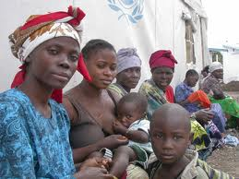

Women in the Democratic Republic of the Congo waiting in line for the clinic

Once a filovirus outbreak has been recognized, the response by MSF and WHO together with laboratory support by US-CDC or Public Health Agency Canada (PHAC) worked quite efficiently during the last outbreaks. It is, however, necessary to mention that in many cases the outbreaks are already waning by the time foreign help arrives.

Actions Needed to Mitigate Filovirus Outbreaks

Short-term solutions (implemented by first responders)
1)-Deploy experts to set up isolation facilities and surveillance systems in affected areas.
2)-Supply medical facilities with bedding, antibiotics, clean water and saline, disposable needles and sample vials, disinfectants, pain-killers, surgical tools.
3)-Protect health care workers in the outbreak zone. Supply them with personal protective gear, disposable needles, gauze, band aids, hospital gowns, disinfecting solutions.
4)-Maintain high standards of patient care by making compassionate use of therapeutic agents from early-stage clinical trials and by using advanced life support (e.g. dialysis) to prevent multi-organ failure (22).
5)-Increase screening at nearby commercial hubs to prevent sick people from entering or leaving the outbreak zone.

Long-term solutions (recommended action items for the GVN)
1) -Local hospitals must be empowered with diagnostic capabilities so they need not rely on distant diagnostic facilities.
2) -Local hospitals must periodically (once a year) run through the drill of setting up isolation facilities and establishing communications with global first responders (CDC, Médecins Sans Frontières, etc).
3) -The public must be educated to prevent them from coming in close contact with sick people or from eating "bushmeat" from dead animals.
4) The export of “bushmeat” that could be a source of outbreaks outside Africa, must be more highly regulated. It is estimated that 13,000 lbs of “bushmeat” are smuggled into the UK every year (32).
5) -Structural studies on filoviruses are needed as a basis for in silico anti-viral drug design. At the Scripps GVN Center, Erica Ollmann Saphire's lab contributes molecular images of ebolavirus proteins for use in targeting antibodies (23-27). X-ray structures show how key neutralizing antibodies bind critical "Achilles Heel" sites on the virus surface. Ongoing work tests the best cocktails of synergistic antibodies for therapeutic use. Studies on interactions between viral and host proteins also highlight specific targets for therapy.

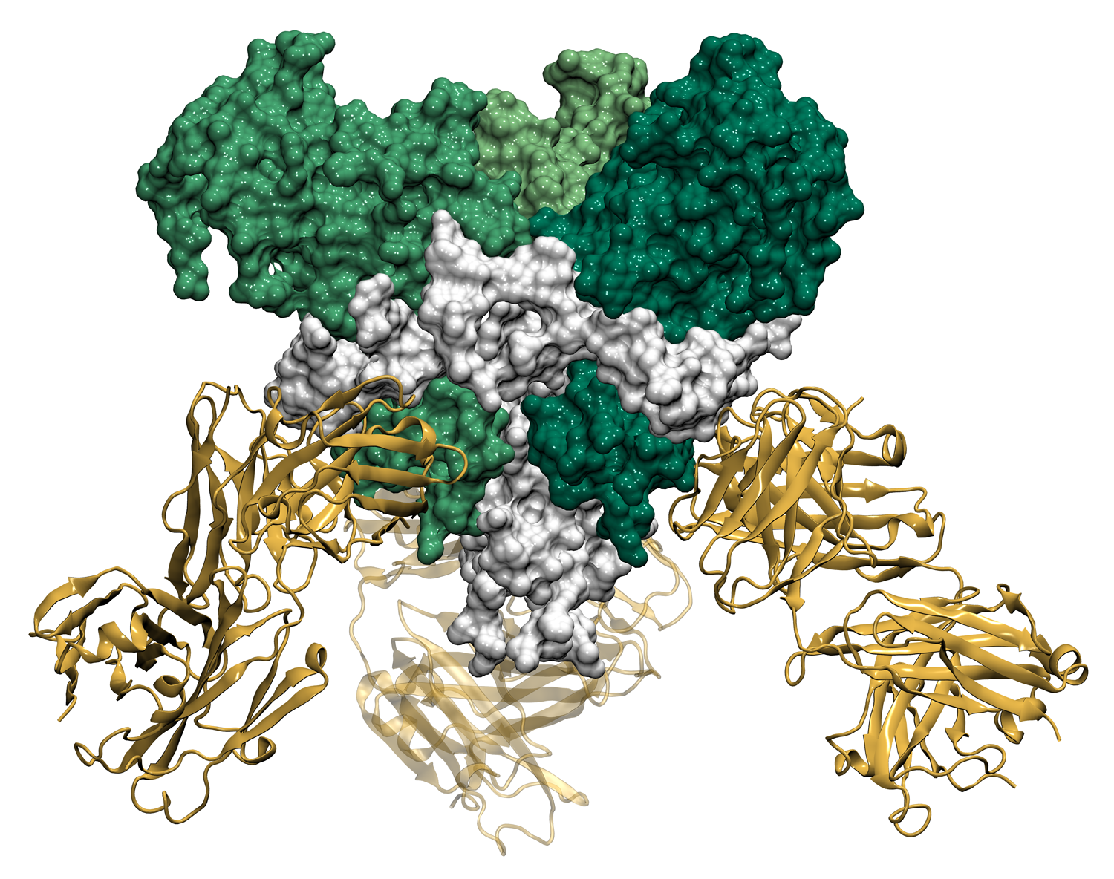
Structural studies of the SUDV in the Saphire lab show how the viral glycoprotein (3 green subunits plus 3 white fusion subunits) can complex with a neutralizing antibody (yellow). This antibody, produced in collaboration between USAMRIID and the Scripps GVN center, locks the subunits together preventing infection.

6) -Research on antiviral drugs is needed: high throughput screens and tests in animal models. The anti-pox drug, Gleevec, was found to work against EBOV in vitro, but it makes mice ill. Some promising RNAi and monoclonal antibodies have been identified; however more funding is needed to test these treatments in primate models.
7) -Research is needed on a polyvalent vaccine (to EBOV, BDBV, and SUDV as well as to Marburg virus) (35). Hopefully it will be a vaccine that can work quickly and can even work after exposure to virus. This vaccine should be made available (via compassionate use) for health care workers and patients known to be recently infected. Vaccines should be designed to be distinguishable from natural infections.
8) –Research is needed to address the pathogenicity of RESTV. For example, ebolavirus VP35 (28, 29) and VP24 (30, 31) are thought to contribute to virulence; so, how do they compare in functional assays when they are derived from virulent and non-virulent strains of virus. Are there mutations that determine virulence in human or nonhuman primates?
9) -Mathematical modeling is needed to predict population dynamics between attenuated and virulent strains of Ebola. In many viral systems, attenuated and virulent strains co-exist. In some cases, attenuated strains dominate and protect animals from the virulent strains. What conditions allow virulent strains to emerge?
10) –Clinical trials are needed to test new treatments and vaccines. The anti-vaccine sentiment shown towards the polio vaccine in some African countries, which was caused by the rumor the vaccine sterilizes African men, shows that trust in new drugs and vaccines is a crucial issue. This needs to be addressed before a vaccine can be offered to people in endemic areas.

Recommendations for Government Policy
Position papers by the GVN come at the interface of science and government policy. They must lay out the facts and suggest a reasonable course of action. The governments must weigh proposed research needs, environmental impact, and impact on their people and resources. The following recommendations are offered:
1) Government policies should be in place in the event that surveillance uncovers "ebolavirus" in the absence of disease. The "Ebola belt" is seen as a disease hotspot, so surveillance efforts are likely to find ebolavirus-seropositive animals (wild and domestic) with no evidence of disease. Local Ministers of Health should decide between two opposing views: a) healthy sero-positive animals represent a dangerous reservoir and should be exterminated to protect mankind, and b) healthy seropositive animals should be ignored since they are not immediately threatening. Policies should demand that well-informed action follow such discoveries. In general, animals carrying virus should be avoided (if wild), trapped and killed (if entering homes), and quarantined and evaluated seriously (if domestic).
When the RESTV was found in healthy swine in the Philippines, it was felt that the amplification of virus in the respiratory secretions of pigs and the potential for natural mutation rendered it a significant concern for public health (13). On the other hand, some may argue that the risk of virulent mutations arising naturally is very low. Field studies with Rift Valley Fever show that attenuated variants tend to drown out virulent outbreaks (33), and vaccine efforts with polio and smallpox show that the incidence of virulent outbreaks after vaccination with attenuated forms is one in millions (34). Policies could be in place to quarantine seropositive animals, to observe their health during a reasonable incubation period, and to release such animals to the herd if they remain healthy. Considering that isolates of RESTV were lethal for laboratory macaques, it would be important to determine the impact of variants harbored by domestic animals on surrounding wild-life (18).
2) A network of African laboratories should be established to increase the capacity for providing rapid differential diagnosis of suspected hemorrhagic fevers. A sustained close contact between African and GVN partner labs can be envisaged to increase the technical knowledge and help to equip the labs properly. Regular exchange of scientists in both directions is the building block to keep the connection alive. For the beginning it would be prudent to support already existing laboratories in regional centers of the “Ebola belt” that might need more financial and scientific support to become expert labs. Identification of those labs should be done in close collaboration with partners which have extended experience in the field (e.g. WHO). This action is in agreement with two of the tasks of GVN: training of young scientists in medical virology and establishing a worldwide network of virologist to be better prepared for outbreaks of emerging viruses.

References
1. WHO websites on outbreaks http://www.who.int/csr/don/2012_09_05/en/index.html and Ebola fact sheets http://www.who.int/mediacentre/factsheets/fs103/en/index.html last accessed 9-15-2012.
2. Shoemaker T, Macneil A, Balinandi S, Campbell S, Wamala JF, McMullan LK, Downing R, Lutwama J, Mbidde E, Ströher U, Rollin PE, Nichol ST. Reemerging Sudan ebola virus disease in Uganda, 2011.Emerg Infect Dis. 2012 Sep;18(9):1480-3.
3. Kuhn, J.H., Becker, S., Ebihara, H., Geisbert, T.W., Jahrling, P.B., Kawaoka, Y., Netesov, S.V., Nichol, S.T., Peters, C.J., Volchkov, V.E. and Ksiazek, T.G 2012. Virus Taxonomy:9th Report of the ICTV. p665-671 AcademicPress: NY, NY 2012
4. Kuhn, J.H., Becker, S., Ebihara, H., Geisbert, T. W., Johnson, K.M., Kawaoka, Y., Lipkin, W.I., Negredo, A.I., Netesov, S.V., Nichol, S.T., Palacios, G., Peters, C.J., Tenorio, A., Volchkov, V.E. and Jahrling, P.B. (2010). Proposal for a revised taxonomy of the family Filoviridae: classification, names of taxa and viruses, and virus abbreviations. Arch. Virol., 155, 2083–2103.
5. Leroy EM, et al, 2005. Nature 438:575.
6. Kobinger GP, et al, 2011. J. Infect. Dis. 204, 200
7. Wamala JF, et al., 2010. Emerg. Infect. Dis. 16, 1087.
8. World Health Organization, 1992. Wkly Epidemiol. Rec. 67: 142.
9. Centers for Disease Control, 1990. Morbid. Mortal. Wkly. Rep. 39: 22.
10. Rollin PE, et al., 1999. J. Infect. Dis. 179 Suppl 1, S108.
11. Wkly Epidemiol. 2009. Rec. 84: 49.
12. Euro Surveill 2009. 14.
13. Marsh GA et al., 2011. J. Infect. Dis. 204 Suppl 3, S804.
14. Becker S, Daniels P, Demetrio C., Feldmann H, Geisbert T, Jahrling P, Kawaoka Y, Koopmans M, Ksiazek T, Leroy E, Mackenzie J, Miranda ME, Nichol S, Peiris M, Rollin P, Swanepoel B, Zaki S, Zeller H. 2009. WHO experts consultation on Ebola Reston pathogenicity in humans. Geneva, Switzerland [this can be found online at http://www.who.int/csr/resources/publications/WHO_HSE_EPR_2009_2/en/index.html]
15. Hoenen T, Groset A, Feldmann H, 2012. Expert Opin Biol Ther 12: 859.
16. Marzi A, Feldmann H, Geisbert T, Falzarano D, 2011. J Bioterrorism & Biodefense S1.
17. Richardson JS, Dekker JD, Croyle MA, Kobinger GP, 2011. Human Vaccines 6: 439.
18. Ryan SJ, Walsh PD Consequence of non-intervention for infectious disease in African great apes. PLoS ONE 6, e29030.
19. Calvignac-Spencer S, S. A. Leendertz, T. R. Gillespie, F. H. Leendertz, 2012. Clinical microbiology and infection : the official publication of the European Society of Clinical Microbiology and Infectious Diseases 18, 521
20. S. Gunther et al., 2011. J. Infect. Dis. 204 Suppl 3, S785
21. Feldmann H., et al., 2007. PLoS Pathog. 3, e2.
22. Ippolito G, Feldmann H, Lanini S, Vairo F, Di Caro A, Capobianchi MR and Nicastri E. 2012 BMC Medicine. 10:31.
23. Dias JM. et al . 2011, Nat. Struct. Mol. Biol. 18, 1424 .
24. Lee JE, et al., 2008. Nature 454, 177 .
25. Lee JE, E. O. Saphire,2009. Future Virol. 4, 621.
26. Bale S, et al., 2012. Viruses 4, 447-70.
27. Bale S, et al., 2011. PLoS neglected tropical diseases 5, e1395.
28. Kimberlin CR, 2010. et al., Proc. Natl Acad. Sci. USA 107, 314.
29. Bale S et al., September 2012, PLoS Pathog. in press, September 2012, Vol 8, Issue 9, e1002916.
30. Zhang AP, et al., 2012. PLoS Pathog. 8, e1002550.
31. Zhang AP, Bornholdt, T. Liu, V. L. Woods-Jr., E. O. Saphire, 2012. Virulence,
32. Website on Bushmeat problem published in The Independent Sept 2012: http://www.independent.co.uk/life-style/health-and-families/health-news/african-monkey-meat-that-could-be-behind-the-next-hiv-7786152.html
33. Lihoradova O et al, 2012, The dominant negative inhibition of dsRNA-dependent protein kinase PKR increases the efficacy of Rift Valley fever virus MP-12 vaccine. J Virol. 86:7650.
34. Peters CJ and Olshaker M. 1998. Virus Hunter: Thirty Years of Battling Hot Viruses Around the World. Anchor Books, Random House:NY, NY
35. Grant-Klein RJ, Van Deusen NM, Badger CV, Hannaman D, Dupuy LC, Schmaljohn CS. 2012. A multiagent filovirus DNA vaccine delivered by im electroporation completely protects mice from ebola and Marburg virus challenge. HumVaccImmunother. vol. 8 (Epub)

Contributors to this position paper: Stephan Becker (Marburg, Germany), Tom Geisbert (UTMB, Galveston, TX), Tom Ksiazek (UTMB, Galveston, TX), Jim LeDuc (UTMB, Galveston, TX), Maria Salvato (IHV-UMD, Baltimore, MD), Erica Ollmann Saphire (TSRI, La Jolla, CA), Connie Schmaljohn (USAMRIID, Frederick, MD). Stuart Nichol and Cathy Roth were embroiled as first-responders.

